Multi-City Air Quality Forecasting in Bangladesh Using Rolling Time-Series Validation
Meherab Hossain Shafin¹*
¹ Daffodil International University, Dhaka, Bangladesh
Correspondence:
Meherab Hossain Shafin
Email: meherabhossainshafin@gmail.com

Abstract
Objective
Short-term air quality forecasting is important for public health advisories, urban planning, and environmental risk management in rapidly urbanizing regions. Bangladesh frequently experiences elevated particulate pollution levels, particularly in major metropolitan areas. This study develops and evaluates a multi-city forecasting pipeline designed to generate short-horizon predictions of PM2.5 concentrations across major Bangladeshi cities.
Results
Hourly air-quality data were obtained through the Open-Meteo environmental API for eight major cities in Bangladesh (Dhaka, Chattogram, Khulna, Rajshahi, Sylhet, Barishal, Rangpur, and Mymensingh). A data ingestion pipeline was implemented to retrieve and store pollutant measurements in a structured SQLite database. Forecasting performance was evaluated using autoregressive integrated moving average (ARIMA) and seasonal autoregressive integrated moving average (SARIMA) models under strict rolling-origin validation to simulate real-time prediction conditions.
Model performance varied across cities. ARIMA achieved the lowest prediction error in Dhaka, Khulna, Rajshahi, and Rangpur, while SARIMA performed better in Barishal, Chattogram, Mymensingh, and Sylhet. Forecast accuracy ranged from RMSE = 1.53 to RMSE = 11.40 depending on city-specific dynamics. These results suggest that short-term PM2.5 dynamics differ across urban environments, and no single model structure universally dominates across locations.
The implemented system demonstrates that a lightweight, reproducible forecasting pipeline can provide reliable short-term air-quality predictions using interpretable time-series models and automated data ingestion.

Introduction
Air pollution represents a major environmental and public health challenge worldwide. Fine particulate matter (PM2.5) is particularly harmful due to its ability to penetrate deep into the respiratory system, contributing to cardiovascular and pulmonary diseases. South Asian megacities frequently experience elevated PM2.5 concentrations driven by traffic emissions, industrial activity, construction dust, and regional atmospheric transport.
Bangladesh has experienced rapid urbanization over the past two decades, with cities such as Dhaka and Chattogram experiencing significant population growth and increasing environmental pressure. Reliable short-term air-quality forecasting can support public health decision-making by enabling early warnings during high-pollution periods.
Time-series forecasting approaches have been widely applied in environmental modeling. Autoregressive frameworks capture temporal persistence in pollutant concentrations, while seasonal models account for cyclical patterns driven by meteorological and anthropogenic factors. Classical statistical approaches such as ARIMA and SARIMA remain widely used due to their interpretability, low computational cost, and strong performance in structured temporal signals.
While machine learning models have been explored for air-quality prediction, interpretable time-series models remain valuable for operational forecasting systems, particularly when data availability is limited and model transparency is important.
This study develops a multi-city forecasting pipeline that integrates automated data ingestion, database storage, time-series modeling, and rolling validation. The goal is to evaluate whether simple autoregressive frameworks can provide reliable short-term PM2.5 forecasts across multiple Bangladeshi cities.
Project Contribution
This project was independently designed and implemented as an end-to-end data science pipeline for short-term air-quality forecasting across major Bangladeshi cities.
The author developed the following components:
Data ingestion system
A Python-based ingestion pipeline was implemented to automatically retrieve hourly air-quality measurements from the Open-Meteo environmental API. The system performs automated API requests, data normalization, and timestamp standardization.
Database architecture
A structured SQLite database schema was designed to store pollutant observations. A composite primary key (city_name, timestamp_utc) was implemented to ensure idempotent ingestion and prevent duplicate records during repeated collection cycles.
Forecasting model implementation
Time-series forecasting models were implemented using the Statsmodels library. Both ARIMA and SARIMA models were configured and trained on city-specific pollutant time series.
Validation framework
A rolling-origin validation procedure was implemented to simulate real-time forecasting conditions and prevent information leakage during model evaluation.
Multi-city evaluation system
The forecasting pipeline was applied to eight major Bangladeshi cities, enabling comparative analysis of model performance across different urban environments.

Methods

Data Sources
Hourly air-quality observations were retrieved using the Open-Meteo environmental API, which provides global atmospheric composition estimates derived from numerical weather prediction and atmospheric chemistry models.
The following pollutants were collected:
- PM2.5 concentration
- PM10 concentration
- Carbon monoxide
- Nitrogen dioxide
- Ozone
Data were collected for eight major cities in Bangladesh:
- Dhaka
- Chattogram
- Khulna
- Rajshahi
- Sylhet
- Barishal
- Rangpur
- Mymensingh
City coordinates were used to retrieve location-specific pollutant measurements
.
City | Latitude | Longitude
Dhaka | 23.8103 | 90.4125
Chattogram | 22.3569 | 91.7832
Khulna | 22.8456 | 89.5403
Rajshahi | 24.3745 | 88.6042
Sylhet | 24.8949 | 91.8687
Barishal | 22.7010 | 90.3535
Rangpur | 25.7439 | 89.2752
Mymensingh | 24.7471 | 90.4203

Table 1. Geographic coordinates of cities used for location-specific air-quality data retrieval.

Data Ingestion Pipeline
A Python-based ingestion system was implemented to automate data retrieval and storage. The pipeline performs the following tasks:
- API requests for hourly pollutant measurements.
- Data normalization and type validation.
- Timestamp standardization in UTC format.
- Persistent storage in a relational SQLite database.
Each observation is indexed using a composite key consisting of:
(city_name, timestamp_utc)
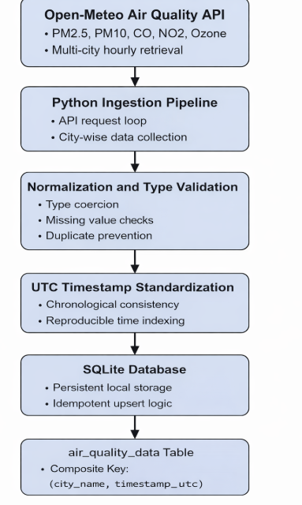
This design ensures idempotent ingestion and prevents duplicate records during repeated data collection cycles.

Figure 1. Data ingestion and storage architecture for the multi-city air-quality forecasting system.

Database Structure
The ingestion pipeline stores observations in the table:
air_quality_data
Key variables include:
Variable | Description
city_name | city identifier
timestamp_utc | observation timestamp
pm2_5 | fine particulate matter concentration
pm10 | coarse particulate matter concentration
carbon_monoxide | CO concentration
nitrogen_dioxide | NO₂ concentration
ozone | O₃ concentration
This structured storage layer enables reproducible dataset extraction for forecasting models.

Dataset Preparation
For forecasting analysis, the primary target variable was PM2.5 concentration, which represents the most widely used indicator of air-quality health risk.
The dataset preparation process involved:
- Extracting city-specific PM2.5 series from the database.
- Sorting observations chronologically.
- Removing missing observations.
- Ensuring consistent hourly time indexing.
This process produced a univariate time series suitable for autoregressive modeling.

Forecasting Models
Two forecasting frameworks were evaluated.

Model Selection Rationale
The forecasting framework focuses on classical statistical time-series models rather than machine learning methods such as gradient boosting or neural networks.
Several factors motivated this design choice.
First, the available dataset contains a relatively short historical window of observations (168 hourly measurements per city). Machine learning models such as XGBoost or deep neural networks typically require substantially larger training datasets to achieve stable generalization. With limited data, such models may overfit the training period and produce unreliable forecasts.
Second, air-quality data exhibit strong temporal dependence and potential periodic patterns associated with daily emission cycles. Autoregressive models such as ARIMA and SARIMA are specifically designed to capture these temporal structures through lagged relationships and seasonal components.
Third, classical time-series models provide a high degree of interpretability. Parameters in ARIMA-based models directly represent autoregressive behavior, differencing operations, and moving-average effects, which allows clearer interpretation of the underlying temporal dynamics compared with many black-box machine learning approaches.
Finally, the primary objective of this study is to demonstrate a reproducible forecasting pipeline rather than to optimize predictive performance through complex model architectures. ARIMA-family models therefore provide a suitable balance between statistical rigor, computational efficiency, and interpretability.
Future work may explore multivariate machine learning approaches incorporating meteorological variables such as temperature, wind speed, and humidity to further improve forecasting performance.
Model Parsimony Considerations
In addition to statistical suitability, model selection was guided by the principle of parsimony, commonly referred to as Occam’s Razor. This principle suggests that, when multiple models provide comparable explanatory power, the simpler model is generally preferable. Given the limited historical dataset and the clear temporal structure of the observations, classical autoregressive models offer a balanced trade-off between predictive capability and model complexity. Introducing high-capacity machine learning models such as gradient boosting or deep neural networks would significantly increase model complexity without sufficient data to justify the additional parameters. Therefore, ARIMA-family models were selected as an appropriate and parsimonious baseline for the forecasting task.

ARIMA Model
The autoregressive integrated moving average model captures temporal dependence in pollutant concentrations through autoregressive and moving-average components.
The general model structure is:
ARIMA(p,d,q)
where:
- p represents autoregressive order
- d represents differencing order
- q represents moving-average order
For this study, the baseline specification was:
ARIMA(2,1,2)

SARIMA Model
Seasonal autoregressive integrated moving average extends ARIMA by modeling periodic temporal structure.
The model form is:
SARIMA(p,d,q)(P,D,Q)s
where s represents the seasonal period.
Because the dataset contains hourly observations, the seasonal period was defined as:
s = 24 hours
The seasonal specification used was:
SARIMA(1,1,1)(1,1,1)24

Validation Strategy
Forecasting models were evaluated using rolling-origin (walk-forward) validation, which simulates real-time prediction conditions.
At each time step:
- The model is trained using all historical observations.
- A one-step-ahead forecast is generated.
- The true value is revealed.
- The training window expands to include the new observation.
Performance metrics include:
Root Mean Squared Error (RMSE)
Mean Absolute Error (MAE)
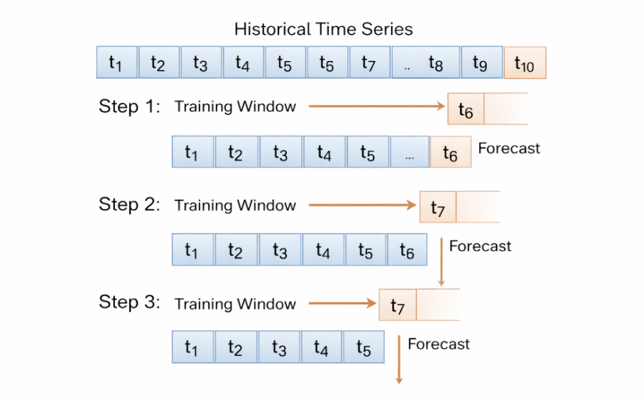

Figure 2. Rolling-origin validation procedure used to simulate real-time forecasting.

Results

Forecasting Performance
Forecast accuracy varied across cities.
City | Best Model | RMSE | MAE
Barishal | SARIMA | 3.27 | 2.54
Chattogram | SARIMA | 1.53 | 1.09
Dhaka | ARIMA | 6.53 | 4.55
Khulna | ARIMA | 5.12 | 2.99
Mymensingh | SARIMA | 7.18 | 5.02
Rajshahi | ARIMA | 11.40 | 8.23
Rangpur | ARIMA | 5.00 | 4.08
Sylhet | SARIMA | 1.92 | 1.33
Table 2. Forecast accuracy comparison across cities using rolling validation.
No single model consistently outperformed across all cities. Forecast accuracy varied across cities, with SARIMA models performing better in Barishal, Chattogram, Mymensingh, and Sylhet, while ARIMA models achieved lower error in Dhaka, Khulna, Rajshahi, and Rangpur. These results indicate that pollution dynamics differ across locations and that no single model structure consistently dominates.

Visualization of Forecast Performance
Model predictions closely tracked short-term fluctuations in observed PM2.5 concentrations.
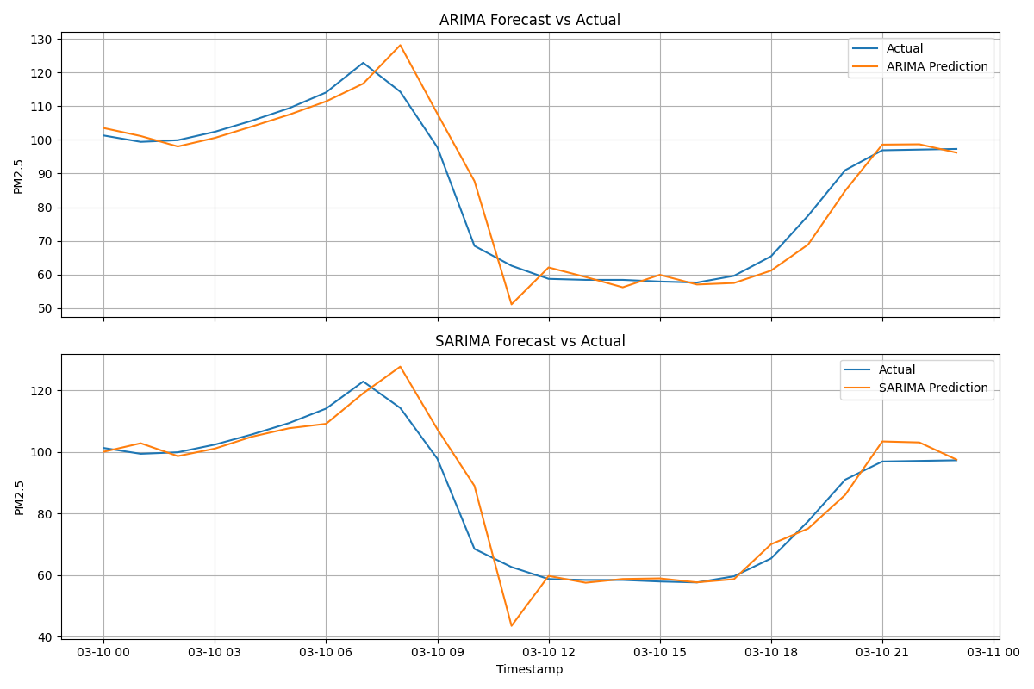Figure 3. Rolling-origin forecast trajectories for PM2.5 concentration in Dhaka. Blue lines represent observed values, while orange lines represent model predictions generated during walk-forward validation.
Seasonal models captured smoother periodic dynamics, while ARIMA models more rapidly adapted to abrupt changes.

Multi-City Model Comparison
To summarize model performance across cities, RMSE comparisons were visualized.
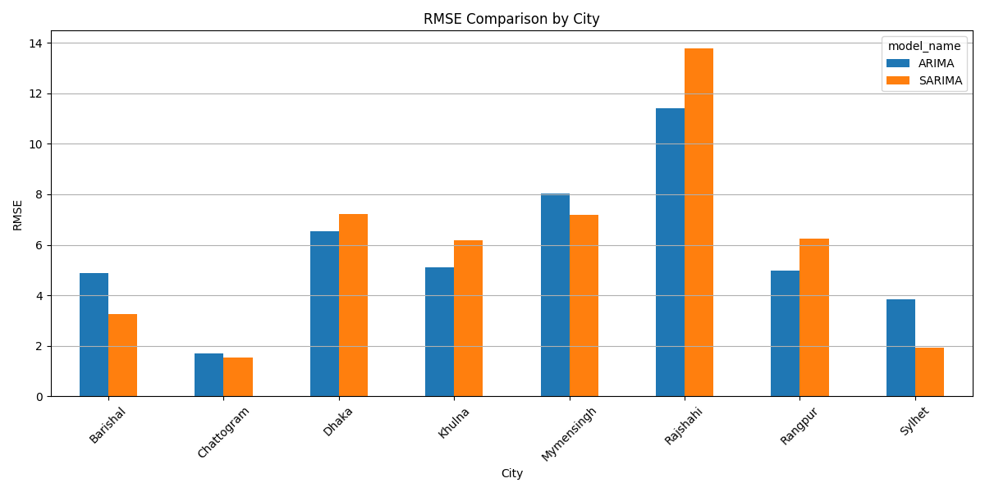Figure 4. Multi-city RMSE comparison between ARIMA and SARIMA models.
Cities exhibiting stronger cyclical pollution patterns tended to favor SARIMA models, while cities with more volatile short-term variation favored ARIMA.

Discussion
This study demonstrates that a lightweight forecasting pipeline can generate accurate short-term PM2.5 predictions using classical time-series models.
Forecasting performance varied significantly across cities, suggesting that local environmental dynamics influence pollutant behavior. Urban areas with strong daily pollution cycles benefited from seasonal modeling, while cities with more irregular fluctuations favored simpler autoregressive structures.
Importantly, the system emphasizes model interpretability and reproducibility. Unlike complex machine learning approaches, ARIMA and SARIMA models provide transparent parameterization and can be implemented with minimal computational resources.
The automated data pipeline also highlights the feasibility of integrating real-time environmental data sources into forecasting workflows.

Limitations
Several limitations should be considered.
- The historical observation window is relatively short.
- Meteorological variables were not explicitly incorporated into forecasting models.
- Pollution sources such as traffic intensity and industrial activity were not included.
- Forecast evaluation focused on short-term horizons.
Future work may explore multivariate models incorporating meteorological covariates and regional pollutant transport.

Technologies and Tools
The forecasting pipeline was implemented using the following technologies:
Programming language
Python
Data processing
Pandas
Time-series modeling
Statsmodels
Database
SQLite
Forecasting techniques
ARIMA
SARIMA
Evaluation methodology
Rolling-origin (walk-forward) validation

Conclusion
This study implemented and evaluated a multi-city air-quality forecasting pipeline for Bangladesh. Using rolling-origin validation, both ARIMA and SARIMA models produced reliable short-term predictions of PM2.5 concentrations.
Model performance differed across cities, indicating that no single forecasting structure universally dominates. The results support the use of parsimonious autoregressive models as practical tools for operational air-quality forecasting.
The proposed system demonstrates how automated data ingestion, database management, and statistical modeling can be integrated into a reproducible environmental forecasting framework.

Key Lessons Learned
This project provided practical experience in designing an end-to-end data science workflow, including automated data ingestion, database design, statistical time-series modeling, and forecast evaluation.
The study highlights the importance of selecting evaluation strategies appropriate for temporal data and demonstrates that interpretable statistical models remain effective for environmental forecasting problems when data availability is limited.

